|  |
| --- |
|  |
| HTML |
| Assessment 2 |
|  |
| **Paul McLaughlin** |
|  |

|  |
| --- |
|  |

Notepad ++ code for home page

<!DOCTYPE html PUBLIC "-//W3C//DTD XHTML 1.0 Transitional//EN" "http://www.w3.org/TR/xhtml1/DTD/xhtml1-transitional.dtd">

<html xmlns="http://www.w3.org/1999/xhtml">

<head>

<title>Cartoonz Home page</title>

<link href="style.css" rel="stylesheet" type="text/css" />

</head>

<body bgcolor = "330033">

<h1 style="color:yellow"> Cartoonz </h1>

<p style="color:yellow"> This is a cartoon page for people to find out more information about their favourite cartoons, the site will have information on what the cartoon is about, who created the cartoon, what channel it is on and how long each episode is on for.</p>

<hr></hr>

<a href = "Main page.html"> Cartoonz main </a>

<hr></hr>

<form action = "form complete.asp" method= "post">

<p> which cartoon from this list is your favourite?</p>

<input type="radio" name="cartoon" value="Johnny Bravo"/> Johnny Bravo<br></br>

<input type="radio" name="cartoon" value="Futurama"/> Futurama<br></br>

<input type="radio" name="cartoon" value="Tom and Jerry "/> Tom and Jerry <br></br>

<input type="radio" name="cartoon" value="Scooby Doo "/> Scooby Doo <br></br>

<input type="radio" name="cartoon" value="The Simpsons "/> The Simpsons <br></br>

<input type="radio" name="cartoon" value="Spongebob squarepants "/> Spongebob squarepants <br></br>

<input type="submit" name="Send"/> <input type="reset"/>

</form>

</body>

</html>

Validation

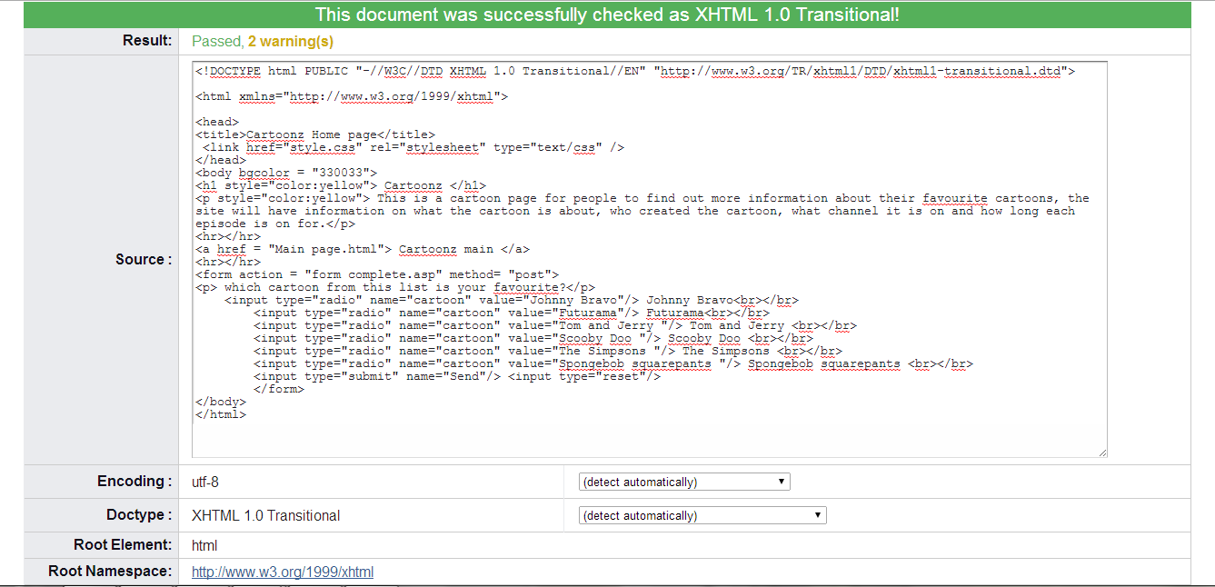

Notepad ++ code for form complete

<!DOCTYPE html PUBLIC "-//W3C//DTD XHTML 1.0 Transitional//EN" "http://www.w3.org/TR/xhtml1/DTD/xhtml1-transitional.dtd">

<html xmlns="http://www.w3.org/1999/xhtml">

<head>

<title>

thanks

</title>

</head>

<body>

<h1> Thank you for answering</h1>

<hr></hr>

<a href = "Home page.html"> Cartoonz home </a>

</body>

</html>

Validation

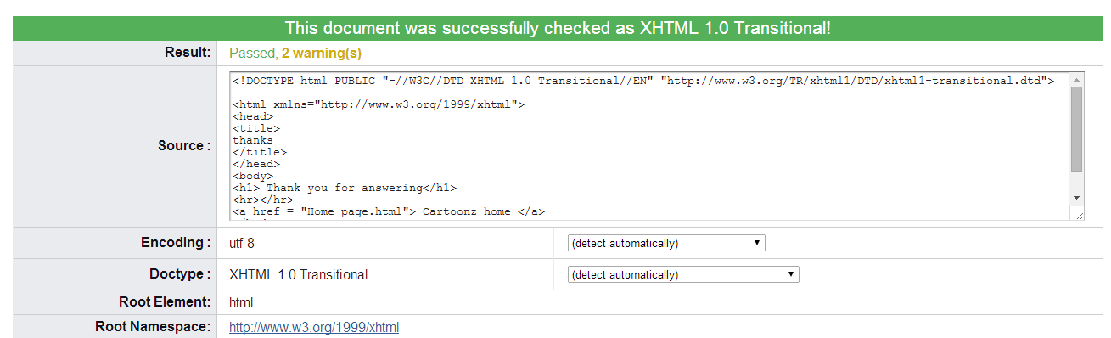

Notepad ++ code for Main Page

<!DOCTYPE html PUBLIC "-//W3C//DTD XHTML 1.0 Transitional//EN" "http://www.w3.org/TR/xhtml1/DTD/xhtml1-transitional.dtd">

<html xmlns="http://www.w3.org/1999/xhtml">

<head>

<title>Cartoon main page</title>

</head>

<body bgcolor = "330033">

<h1 style="color:yellow"> Cartoons </h1>

<p style="color:yellow"> This is a table listing cartoons that you may find out information about </p>

<table width="100%" border="1" cellspacing="4" cellpadding="30">

<tr>

<th bgcolor="006699">Cartoons</th>

<th bgcolor="006699">Channel</th>

<th bgcolor="006699">Day</th>

<th bgcolor="006699">Cartoon Information</th>

</tr>

<tr>

<td bgcolor="006699">Johnny Bravo </td>

<td bgcolor="006699">Cartoon Network </td>

<td bgcolor="006699"> Fridays </td>

<td bgcolor="006699"> <a href = "JohnnyBravo.html"> Johnny Bravo </a> </td>

</tr>

<tr>

<td bgcolor="006699"> Tom and Jerry </td>

<td bgcolor="006699"> Boomerang </td>

<td bgcolor="006699"> Mondays </td>

<td bgcolor="006699"> <a href = "TomandJerry.html"> Tom and Jerry </a> </td>

</tr>

<tr>

<td bgcolor="006699"> Scooby Doo </td>

<td bgcolor="006699"> Cartoon Network </td>

<td bgcolor="006699">Thursday </td>

<td bgcolor="006699"> <a href = "Scooby Doo.html"> Scooby Doo </a> </td>

</tr>

<tr>

<td bgcolor="006699"> The Simpsons </td>

<td bgcolor="006699"> Sky 1 </td>

<td bgcolor="006699"> Sunday </td>

<td bgcolor="006699"> <a href = "Simpsons.html"> The Simpsons </a> </td>

</tr>

<tr>

<td bgcolor="006699"> Spongebob squarepants </td>

<td bgcolor="006699"> Nickelodion </td>

<td bgcolor="006699"> Wednesday </td>

<td bgcolor="006699"> <a href = "Spongebob.html"> Spongebob Squarepants </a> </td>

</tr>

<tr>

<td bgcolor="006699"> Futurama </td>

<td bgcolor="006699"> Sky 1 </td>

<td bgcolor="006699"> Saturday </td>

<td bgcolor="006699"> <a href = "Futurama.html"> Futurama </a> </td>

</tr>

</table>

</body>

</html>

Validation

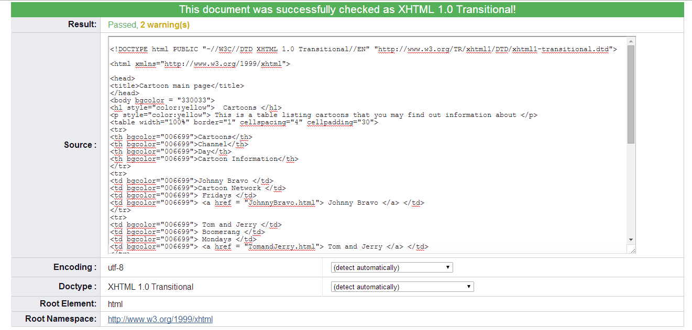

Notepad ++ code for CSS style sheet

body {

background-image: url(bg.jpg);

background-repeat:repeat-x;

}

p {

font-size:.9em;

line-height:170%;

margin-top:0;

margin-left: 25px;

}

Validation

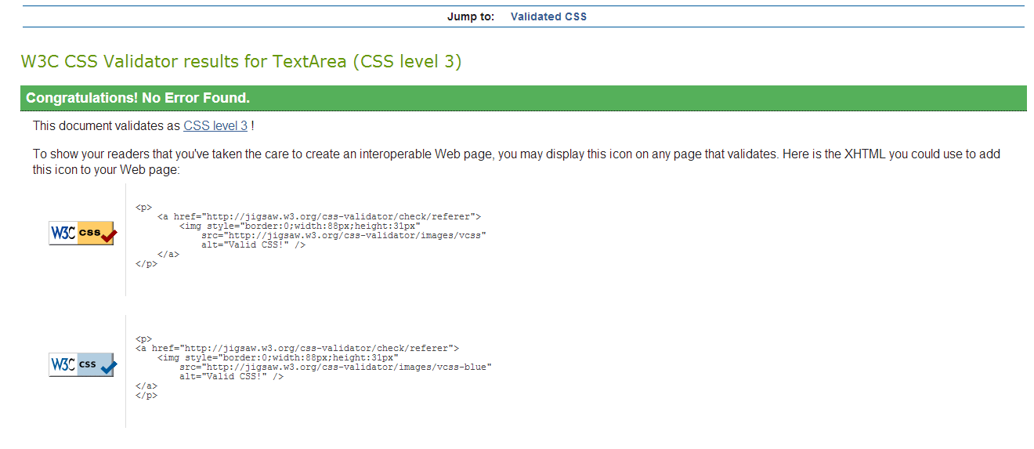

Notepad ++ code for Johnny Bravo page

<!DOCTYPE html PUBLIC "-//W3C//DTD XHTML 1.0 Transitional//EN" "http://www.w3.org/TR/xhtml1/DTD/xhtml1-transitional.dtd">

<html xmlns="http://www.w3.org/1999/xhtml">

<head>

<title>Johnny Bravo</title>

</head>

<body bgcolor = "#00000">

<img src = "johnnybravo.jpg" alt = "no image available"/>

<div style = "color:yellow">

<h1> Johnny Bravo </h1>

</div>

<hr></hr>

<p style="color:white">Johnny Bravo is an American animated television series by Van Partible for Cartoon Network. The series stars a muscular beefcake man named Johnny Bravo who dons a pompadour hairstyle and an Elvis Presley-like voice and has a forward, woman-chasing personality. Plots typically revolve around him trying to get a woman that he has targeted throughout the episode to fall in love with him. He is often beaten up or stunned by his target or companions, or is ditched by them in the end.</p>

<p style="color:white">The series was originally part of a series of shorts on Cartoon Network's animation showcase series World Premiere Toons (also known as the The What a Cartoon! Show). The popularity of the shorts led to the network commissioning a full series for the show, which premiered on July 7, 1997. The series was renewed for multiple following seasons and finally ended its official run on August 27, 2004.</p>

<p style="color:white">The series was the second series to be spun from World Premiere Toons, and is the second series under Cartoon Cartoons (a collective name for early Cartoon Network original series). A spin-off of the series, JBVO, was unsuccessful and ran for one season. Many of the writers and directors on the series went on to become famous for their own projects (writer Seth MacFarlane for Fox's Family Guy, American Dad! and The Cleveland Show and writer/director Butch Hartman for Nickelodeon's The Fairly OddParents, Danny Phantom and T.U.F.F. Puppy). Johnny Bravo is today considered a classic Cartoon Network series, the title character is labeled as "iconic", and his catchphrases (including "Wooaahh, Mama!") are relatively common in popular culture.[1] Reruns of the show are played on Boomerang.</p>

<p style="color:white">A television movie titled Johnny Bravo Goes to Bollywood was made and aired in India in 2009, and in August 2010 in the United Kingdom. A 70-minute movie with the same title aired in Australia on November 20, 2011.</p>

<p style="color:white">As of March 30, 2012, this series has returned to Cartoon Network in reruns on the revived block, Cartoon Planet.</p>

<p style="color:white">Johnny Bravo has received generally positive reviews from critics and is now regarded as a cult hit.</p>

</body>

</html>

Validation

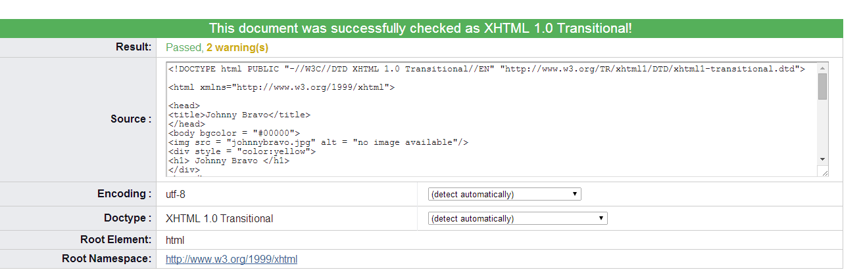

Notepad ++ code for Tom and Jerry page

<!DOCTYPE html PUBLIC "-//W3C//DTD XHTML 1.0 Transitional//EN" "http://www.w3.org/TR/xhtml1/DTD/xhtml1-transitional.dtd">

<html xmlns="http://www.w3.org/1999/xhtml">

<head>

<title>Tom and Jerry</title>

<link href="style.css" rel="stylesheet" type="text/css" />

</head>

<body bgcolor = "3366FF">>

<img src = "tomandjerry.jpg" alt = "no image available"/>

<div style = "color:brown">

<h1>Tom and Jerry</h1>

</div>

<hr></hr>

<p style="color:993300">Tom and Jerry is an American animated series of short films created in 1940 by William Hanna and Joseph Barbera. It centers on a rivalry between its two main characters, Tom Cat and Jerry Mouse, and many recurring characters, based around slapstick comedy. Tom and Jerry has gained a worldwide audience and is one of the most popular and critically acclaimed cartoon series</p>

<p style="color:993300">In its original run, Hanna and Barbera produced 114 Tom and Jerry shorts for Metro-Goldwyn-Mayer from 1940 to 1957. During this time, they won seven Academy Awards for Animated Short Film, tying first place with Walt Disney's Silly Symphonies with the most awards in the category. After the MGM cartoon studio closed in 1957, MGM revived the series with Gene Deitch directing an additional 13 Tom and Jerry shorts for Rembrandt Films from 1961 to 1962. Tom and Jerry then became the highest-grossing film series all of time, overtaking Looney Tunes. Chuck Jones then produced another 34 shorts with Sib-Tower 12 Productions between 1963 and 1967. Two more shorts were produced, The Mansion Cat in 2001 and The Karate Guard in 2005, for a total of 163 shorts. Various shorts have been released for home media since the 1990s.</p>

<p style="color:993300">A number of spin-offs have been made, including the television series The Tom and Jerry Show from 1975 to 1977, The Tom and Jerry Comedy Show from 1980 to 1982, Tom and Jerry Kids from 1990 to 1994, Tom and Jerry Tales from 2006 to 2008, and The Tom and Jerry Show 2014. The first feature-length film based on the series, Tom and Jerry: The Movie, was released in 1992 before ten direct-to-video films were produced between 2002 and 2013.</p>

<p style="color:993300">Numerous Tom and Jerry shorts have been subject to controversy, mainly over racial stereotypes which involves the portrayal of the recurring black character Mammy Two Shoes and characters appearing in blackface. Other controversial themes include cannibalism and the glamorization of smoking.</p>

</body>

</html>

Validation

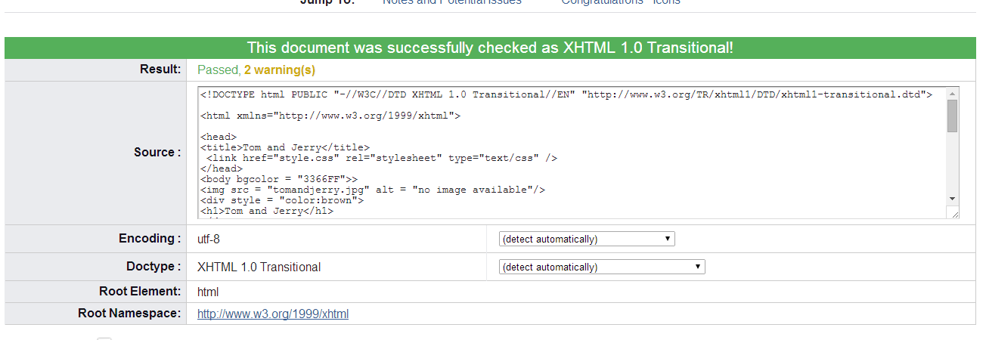

Notepad ++ code for Scooby doo page

<!DOCTYPE html PUBLIC "-//W3C//DTD XHTML 1.0 Transitional//EN" "http://www.w3.org/TR/xhtml1/DTD/xhtml1-transitional.dtd">

<html xmlns="http://www.w3.org/1999/xhtml">

<head>

<title>Scooby Doo</title>

<link href= "style.css" rel = "stylesheet" type= "text/css"/>

<style type = "text/css">

</style>

</head>

<body bgcolor = "99CC00">>

<img src = "scoobydoo.jpg" alt = "image not available"/>

<h1> Scooby Doo </h1>

<hr></hr>

<p>Scooby-Doo is an American animated cartoon franchise, comprising several animated television series produced from 1969 to the present day. The original series, Scooby-Doo, Where Are You!, was created for Hanna-Barbera Productions by writers Joe Ruby and Ken Spears in 1969. This Saturday-morning cartoon series featured four teenagers : Fred Jones, Daphne Blake, Velma Dinkley and Norville "Shaggy" Rogers and their talking brown Great Dane dog named Scooby-Doo, who solve mysteries involving supposedly supernatural creatures through a series of antics and missteps</p>

<p>Following the success of the original series, Hanna-Barbera and its successor Warner Bros. Animation have produced numerous follow-up and spin-off animated series and several related works, including television specials and telefilms, a line of direct-to-video films, and two Warner Bros.–produced theatrical feature films. Some versions of Scooby-Doo feature different variations on the show's supernatural theme, and include characters such as Scooby's cousin Scooby-Dum and nephew Scrappy-Doo in addition to or instead of some of the original characters.</p>

<p>Scooby-Doo was originally broadcast on CBS from 1969 to 1976, when it moved to ABC. ABC aired the show until cancelling it in 1986, and presented a spin-off featuring the characters as children, A Pup Named Scooby-Doo, from 1988 until 1991. Two new Scooby-Doo series, What's New, Scooby-Doo? and Shaggy and Scooby-Doo Get a Clue!, aired as part of Kids WB on The WB network and its successor, The CW network, from 2002 until 2008. The most recent Scooby-Doo series, Scooby-Doo! Mystery Incorporated, aired on Cartoon Network from 2010 to 2013. Repeats of the various Scooby-Doo series are broadcast frequently on Cartoon Network and Boomerang in the United States as well as other countries.</p>

<p>In 2013, TV Guide ranked Scooby-Doo the fifth Greatest TV Cartoon of All Time</p>

</body>

</html>

Validation

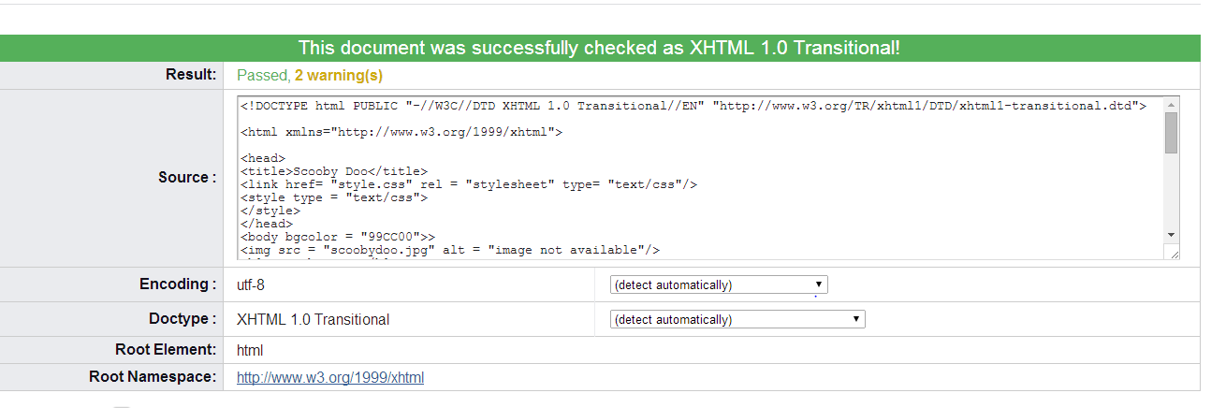

Notepad ++ code for The Simpsons page

<!DOCTYPE html PUBLIC "-//W3C//DTD XHTML 1.0 Transitional//EN" "http://www.w3.org/TR/xhtml1/DTD/xhtml1-transitional.dtd">

<html xmlns="http://www.w3.org/1999/xhtml">

<head>

<title>the Simpsons</title>

<link href= "style.css" rel = "style" type= "text/css"/>

</head>

<body bgcolor = "990000">

<img src = "simpsons.jpg" alt = "no image available"/>

<div style = "color:yellow">

<h1> The Simpsons </h1>

</div>

<hr></hr>

<p style="color:33CCFF">The Simpsons is an American adult animated sitcom created by Matt Groening for the Fox Broadcasting Company. The series is a satirical parody of a middle class American lifestyle epitomized by its family of the same name, which consists of Homer, Marge, Bart, Lisa, and Maggie. The show is set in the fictional town of Springfield and parodies American culture, society, television, and many aspects of the human condition.</p>

<p style="color:33CCFF">>The family was conceived by Groening shortly before a solicitation for a series of animated shorts with the producer James L. Brooks. Groening created a dysfunctional family and named the characters after members of his own family, substituting Bart for his own name. The shorts became a part of The Tracey Ullman Show on April 19, 1987. After a three-season run, the sketch was developed into a half-hour prime time show and was an early hit for Fox, becoming the network's first series to land in the Top 30 ratings in a season from 1989 to 1990.</p>

<p style="color:33CCFF">Since its debut on December 17, 1989, the show has broadcast 545 episodes and the 25th season began on September 30, 2013. The Simpsons is the longest-running American sitcom, the longest-running American animated program, and in 2009 it surpassed Gunsmoke as the longest-running American primetime, scripted television series. The Simpsons Movie, a feature-length film, was released in theaters worldwide on July 26 and 27, 2007, and grossed over $527 million.</p>

<p style="color:33CCFF">The Simpsons is widely considered to be one of the greatest television series of all time. Time magazine's December 31, 1999, issue named it the 20th century's best television series, and on January 14, 2000, the Simpson family was awarded a star on the Hollywood Walk of Fame. It has won dozens of awards since it debuted as a series, including 28 Primetime Emmy Awards, 30 Annie Awards and a Peabody Award. Homer's exclamatory catchphrase "D'oh!" has been adopted into the English language, while The Simpsons has influenced many adult-oriented animated sitcoms.</p>

</body>

</html>

Validation

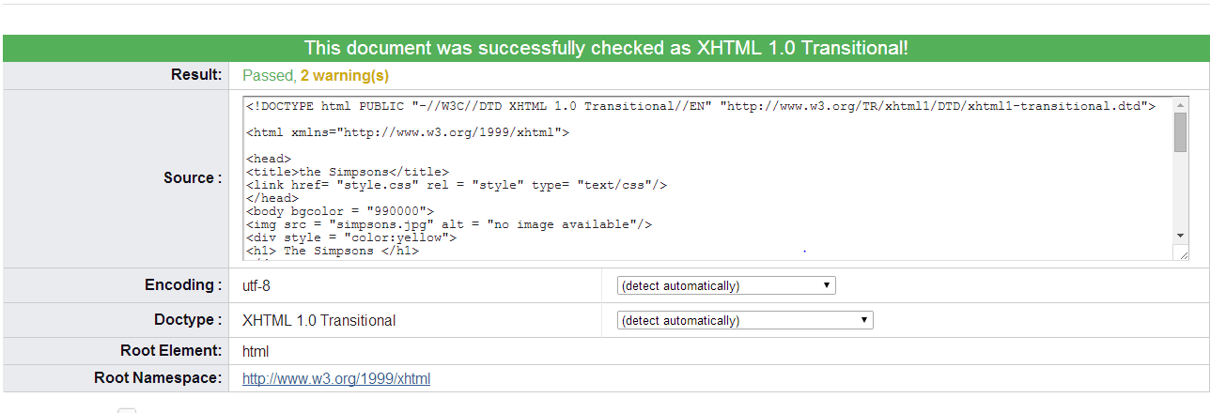

Notepad ++ code for Spongebob page

<!DOCTYPE html PUBLIC "-//W3C//DTD XHTML 1.0 Transitional//EN" "http://www.w3.org/TR/xhtml1/DTD/xhtml1-transitional.dtd">

<html xmlns="http://www.w3.org/1999/xhtml">

<head>

<title>Spongebob Squarepants</title>

<link href= "style.css" rel = "style" type= "text/css"/>

</head>

<body bgcolor = "66CCFF">

<img src = "spongebob.jpg" alt = "image not available"/>

<div style = "color:CCFF00">

<h1>Spongebob Squarepants </h1>

</div>

<hr></hr>

<p style="color:blue">SpongeBob SquarePants (often referred to simply as SpongeBob) is an American animated television series, created by marine biologist and animator Stephen Hillenburg. The series chronicles the adventures and endeavors of the title character and his various friends in the fictional underwater city of Bikini Bottom. The series' popularity has made it a media franchise, as well as Nickelodeon network's highest rated show, and the most distributed property of MTV Networks. The media franchise has generated $8 billion in merchandising revenue for Nickelodeon.</p>

<p style="color:blue">Many of the ideas for the series originated in an unpublished, educational comic book titled The Intertidal Zone, which Hillenburg created in 1984. He began developing SpongeBob SquarePants into a television series in 1996 upon the cancellation of Rocko's Modern Life, and turned to Tom Kenny, who had worked with him on that series, to voice the titular character. SpongeBob was originally to be named SpongeBoy, and the series was to be called SpongeBoy Ahoy!, but these were changed, as the name was already in use for a mop product.</p>

<p style="color:blue">The pilot episode first aired on Nickelodeon in the United States on May 1, 1999, following the television airing of the 1999 Kids' Choice Awards. The series received worldwide critical acclaim upon its premiere and gained enormous popularity by its second season. A feature film, The SpongeBob SquarePants Movie, was released in theaters on November 19, 2004, and a sequel is currently in production, with a projected release date of February 13, 2015. On July 21, 2012, the series was renewed and aired its ninth season, beginning with the episode "Extreme Spots".</p>

</body>

</html>

Validation

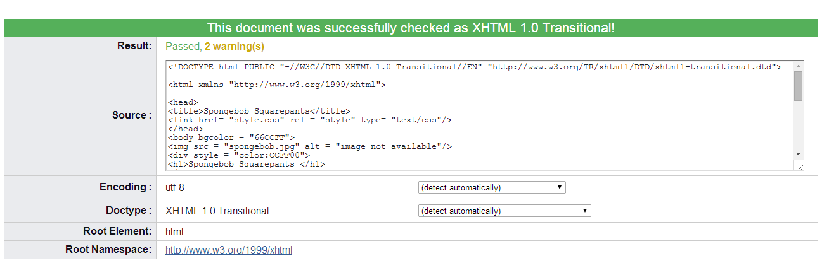

Notepad ++ code for Futurama page

<!DOCTYPE html PUBLIC "-//W3C//DTD XHTML 1.0 Transitional//EN" "http://www.w3.org/TR/xhtml1/DTD/xhtml1-transitional.dtd">

<html xmlns="http://www.w3.org/1999/xhtml">

<head>

<title>Futurama</title>

</head>

<body bgcolor = "990000">

<img src = "Futurama.jpg" alt = "image not available"/>

<h1>Futurama</h1>

<hr></hr>

<p style="color:grey">Futurama is an American adult animated science fiction sitcom created by Matt Groening and developed by Groening and David X. Cohen for the Fox Broadcasting Company. The series follows the adventures of a late-20th-century New York City pizza delivery boy, Philip J. Fry, who, after being unwittingly cryogenically frozen for one thousand years, finds employment at Planet Express, an interplanetary delivery company in the retro-futuristic 31st century. The series was envisioned by Groening in the late 1990s while working on The Simpsons, later bringing Cohen aboard to develop storylines and characters to pitch the show to Fox.</p>

<p style="color:grey">In the United States, the series aired on Fox from March 28, 1999, to August 10, 2003, before ceasing production. Futurama was then aired in reruns on Cartoon Network's Adult Swim from 2003 to 2007, until the network's contract expired. It was revived in 2008 as four direct-to-video films; the last of which was released in early 2009. Comedy Central entered into an agreement with 20th Century Fox Television to syndicate the existing episodes and air the films as 16 new, half-hour episodes, constituting a fifth season.</p>

<p style="color:grey">In June 2009, producing studio 20th Century Fox announced that Comedy Central had picked up the show for 26 new half-hour episodes, which began airing in 2010 and 2011.[3][4] The show was renewed for a seventh season, with the first half airing in June 2012 and the second set for early summer 2013.[5][6] It was later revealed that the seventh season would be the final season, as Comedy Central announced that they would not be commissioning any further episodes. The series finale aired on September 4, 2013,[7] though Groening has said he will try to get it picked up by another network.</p>

<p style="color:grey">Throughout its run, Futurama has received critical acclaim. The show has been nominated for 17 Annie Awards and 12 Emmy Awards, winning seven of the former and six of the latter. It has also been nominated four times for a Writers Guild of America Award, winning two for the episodes "Godfellas" and "The Prisoner of Benda", been nominated for a Nebula Award and has received Environmental Media Awards for episodes "The Problem with Popplers" and "The Futurama Holiday Spectacular".[9] Futurama-related merchandise has also been released, including a tie-in comic book series and video game, calendars, clothes, and figurines.</p>

</body>

</html>

Validation

